**NAME: AQSA TAUHEED (2303-KHI-DEG-011)**

**PAIRING WITH : MAVIA ALAM KHAN (2303.KHI.DEG.017)**

**&**

**MOHAMMAD HUSSAM(2033.KHI.DEG.020)**

_____________________________________________________________________________________

**ASSIGNMENT NO : 4.1**

Browse to:  
tasks/4_microservices_development/day_1_microservices/doc  
ker_compose_example  
Next you will:  
- Start the system using docker-compose so that it runs in  
background,  
- Visit http://127.0.0.1/ to see WordPress installation panel,  
- See the system logs  
- Add a PHPMyAdmin service from  
https://hub.docker.com/r/phpmyadmin/phpmyadmin/ so that  
you can manage the raw database contents.

**SOLUTION:**

**STEP#1:**

First we opened the yaml file from that example in vs code , that will be like this :

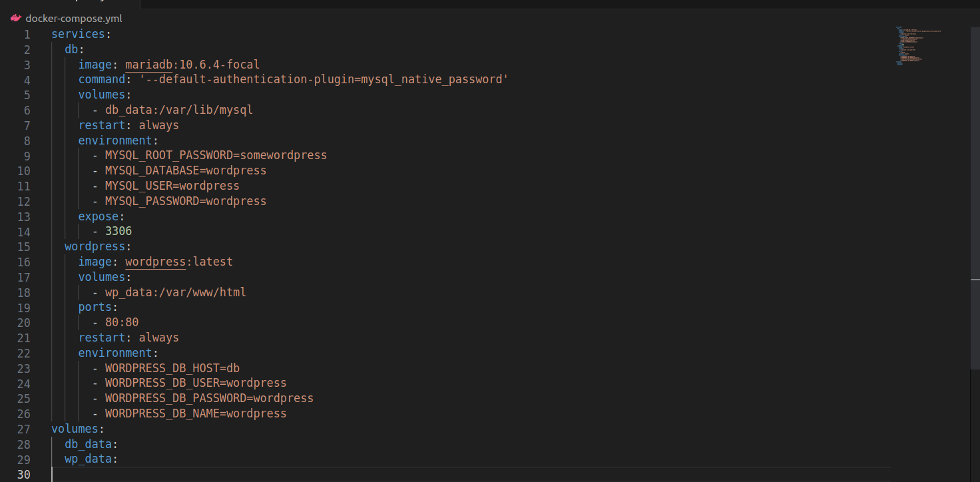

Now we run command docker-compose up –d . This will start the two containers defined in the docker-compose file - db and wordpress - in detached mode (in the background).

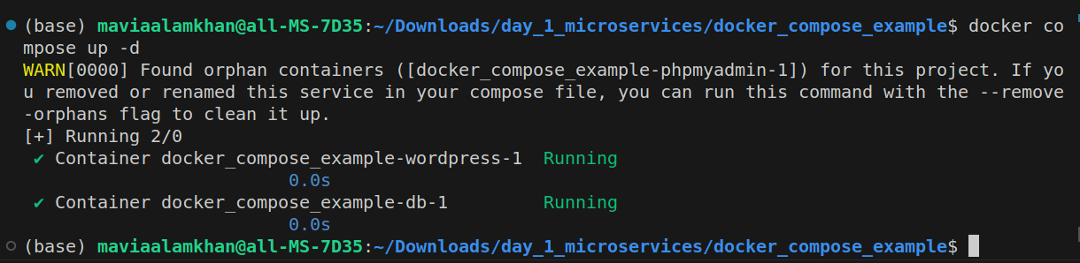

**STEP#2**

[http://localhost:80](http://localhost:80/)

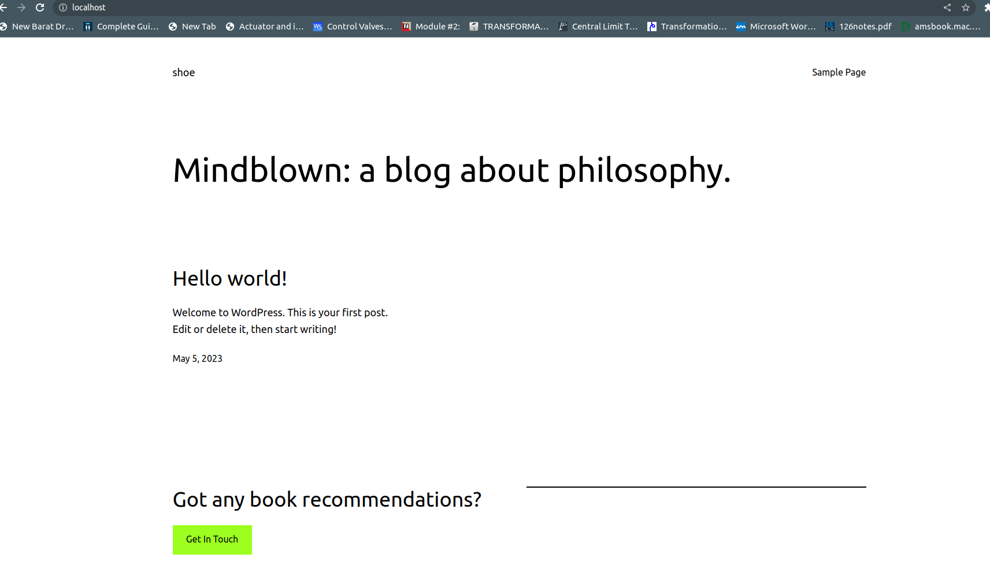

Here I have already installed the word press and set up it so it looks like above.

**STEP#3:**

To see the logs for the system, run the following command:

docker compose logs

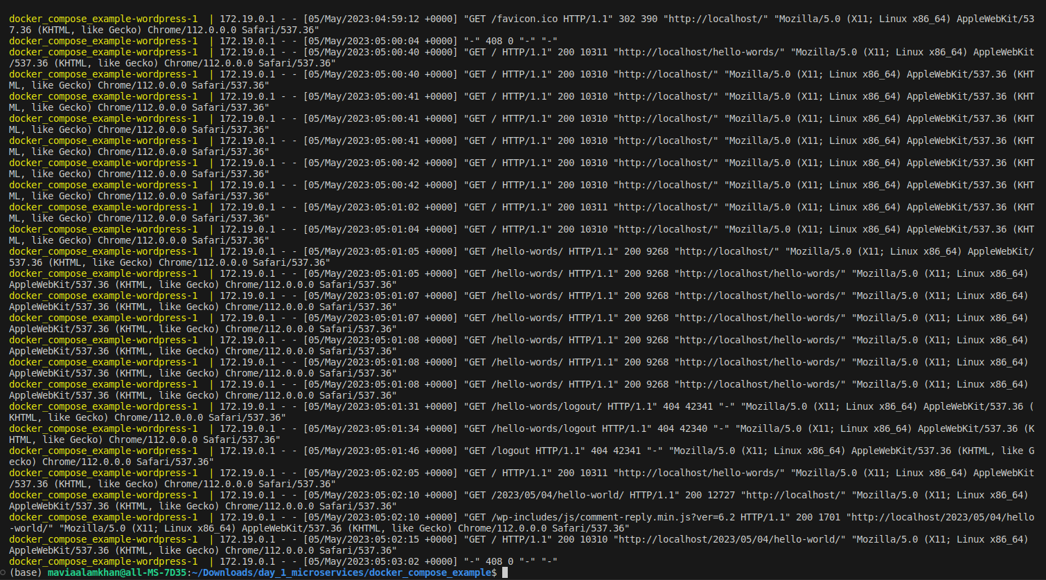

This will display the logs for all the services running in the docker-compose environment.

**STEP#4:**

Modifiying the yaml file by new service PHPMyAdmin service, so file should look like as:

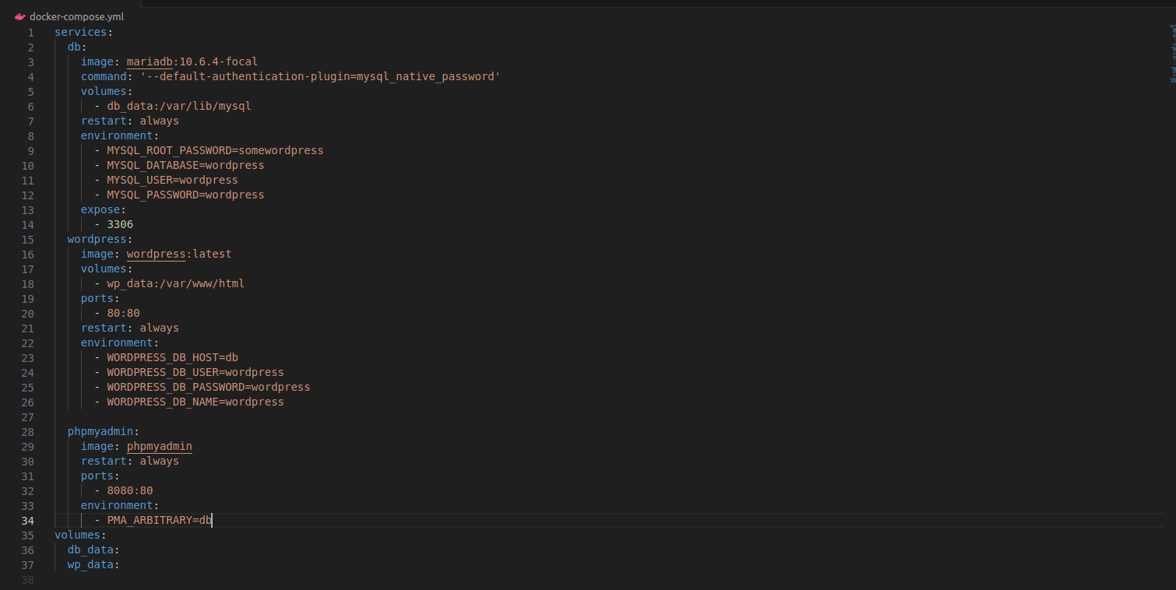

**STEP#5**

Now we use the docker compose up –d command again.

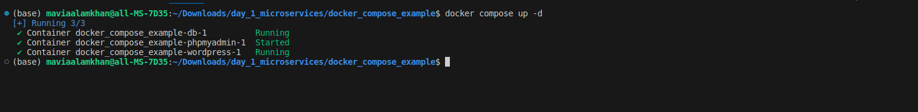

**STEP#6**

Visit <http://localhost:8080/> in your web browser to access the PHPMyAdmin interface and manage the database contents.

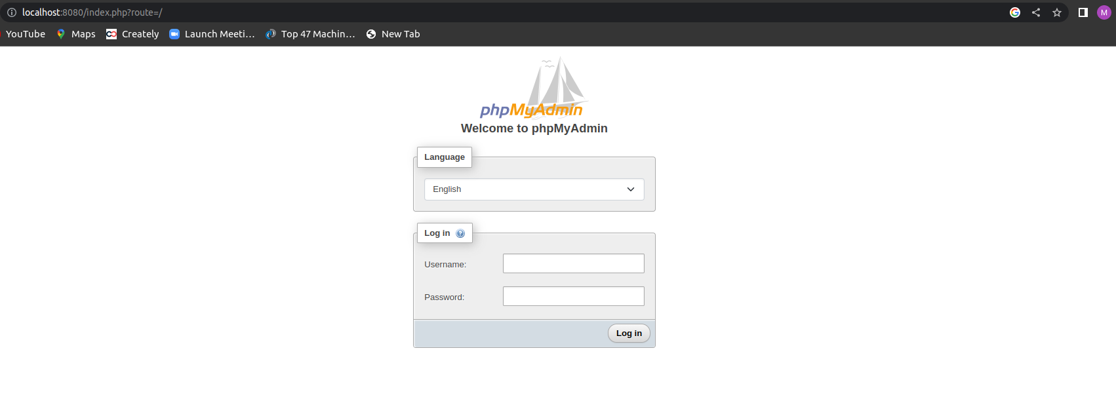

After login:

